Assignment – 01
Database

Name : Tuba Jan
Std_ID : CSC-25F-602
Teacher : Dr Sarmad Shaikh
Department : Computer Science
Section : IIC
Company Database:
Created database of company using MySQL
MySQL Interface:
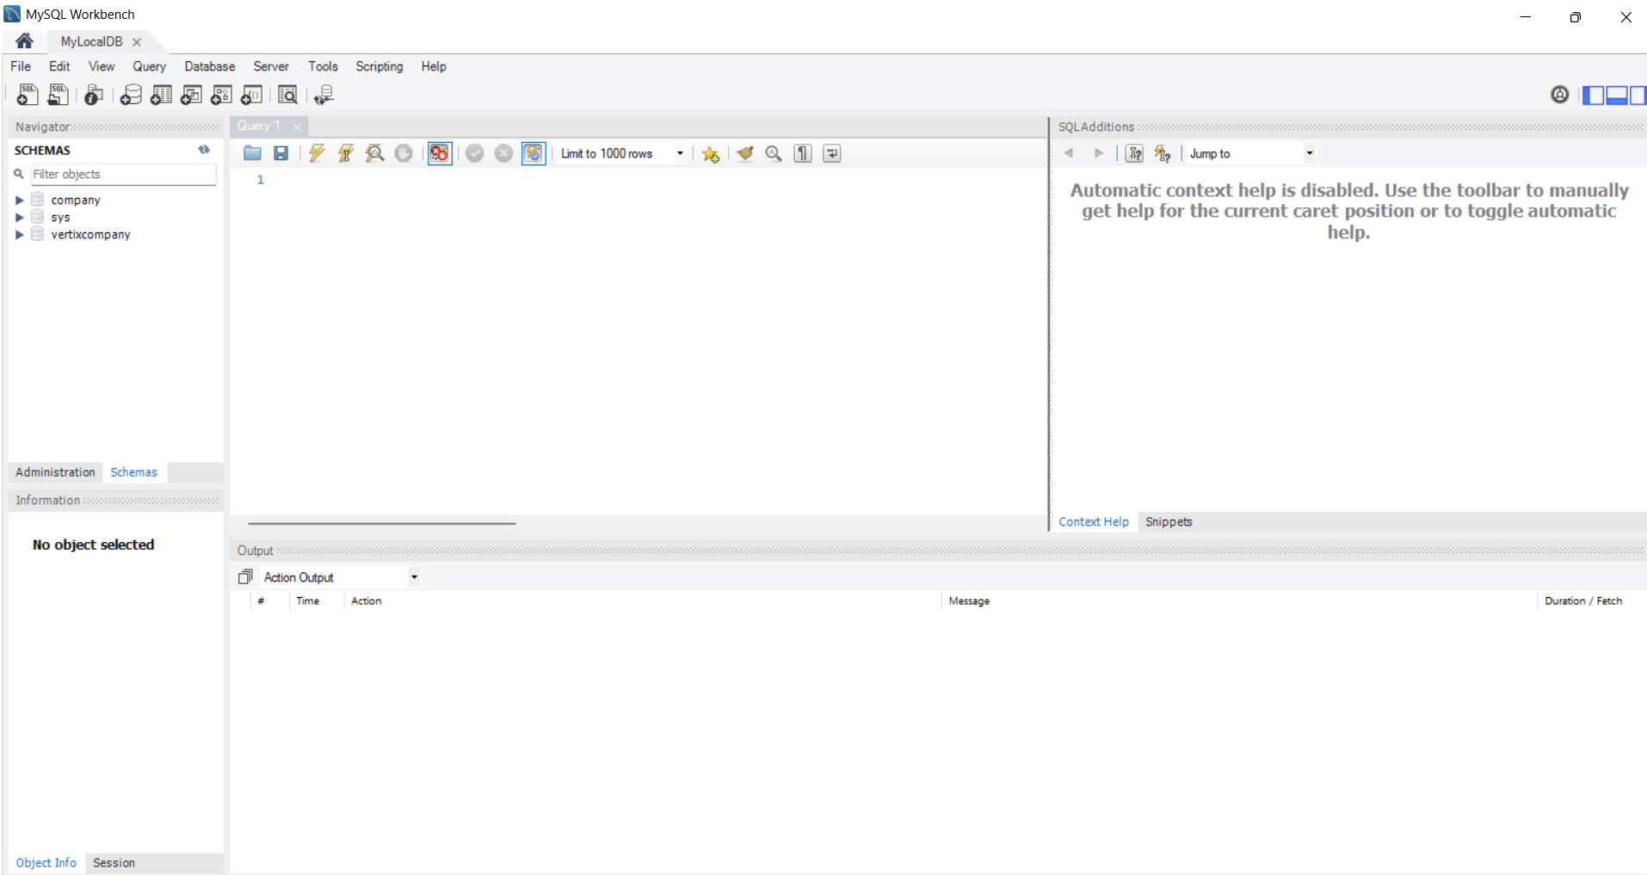

Create Database : Company
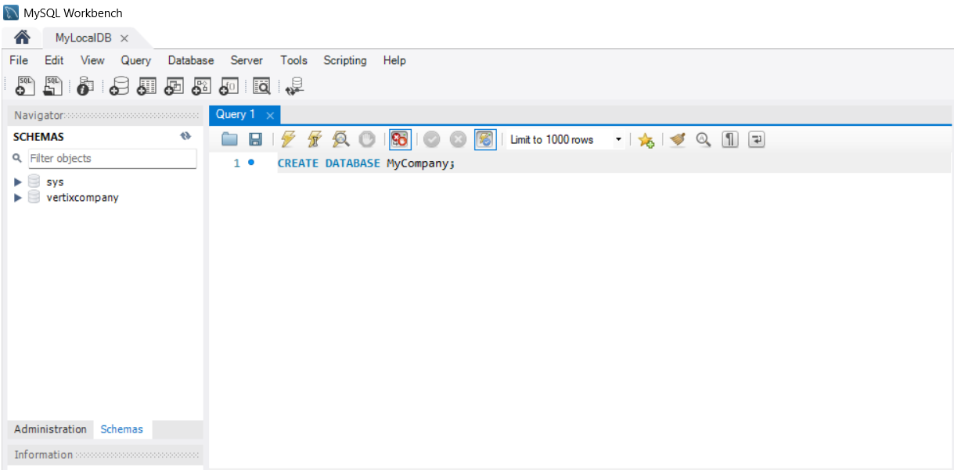
Tables :
Creating tables and run (Thunder Button)
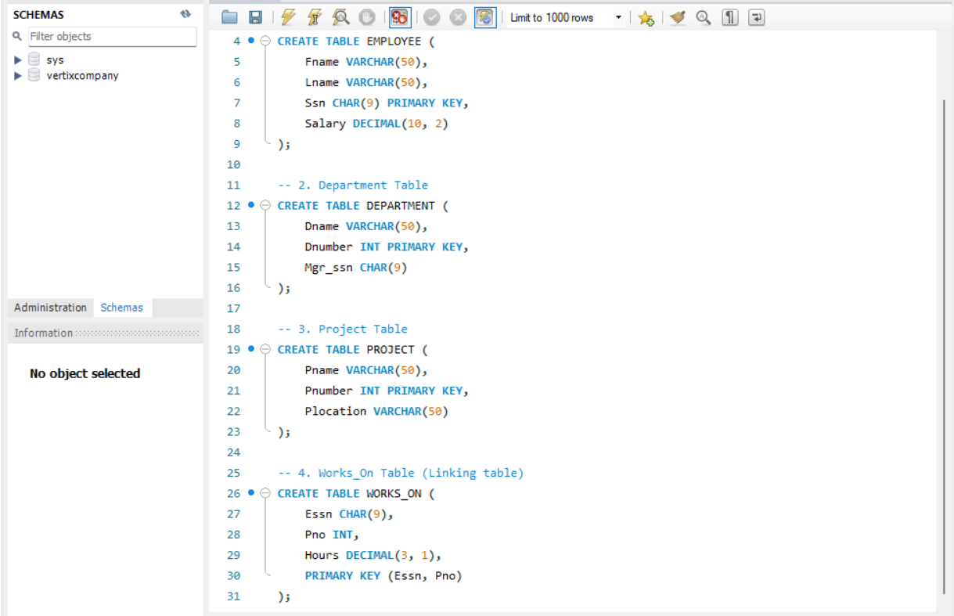

Adding Data :
Inserting data of tables Employees , Department , Project , Works_on
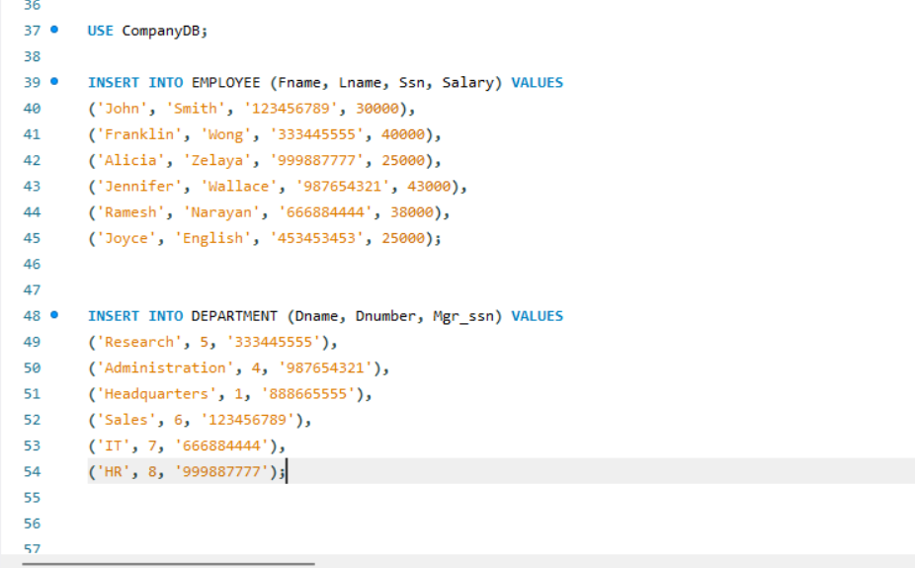
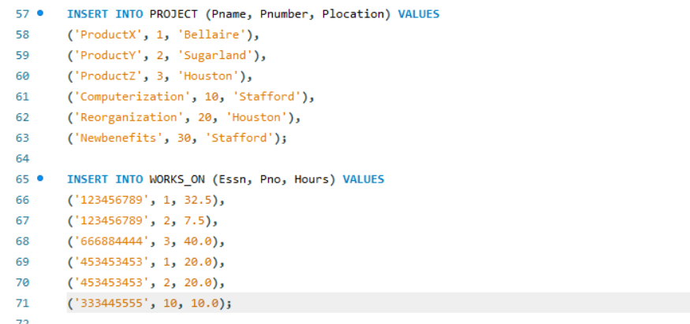

Execute the selected portion.

Data Shown in tables form :

Employees :
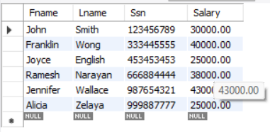

Project:
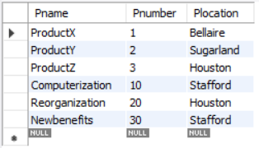

Department:
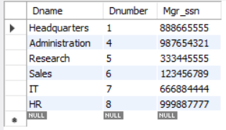

Works_on :
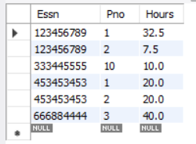

Creating Primary Keys:
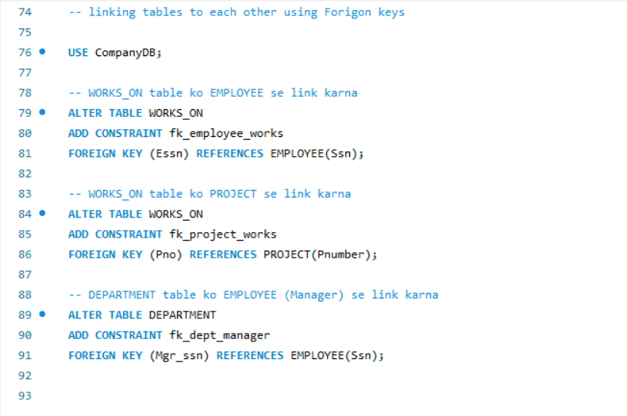

EER Diagram :
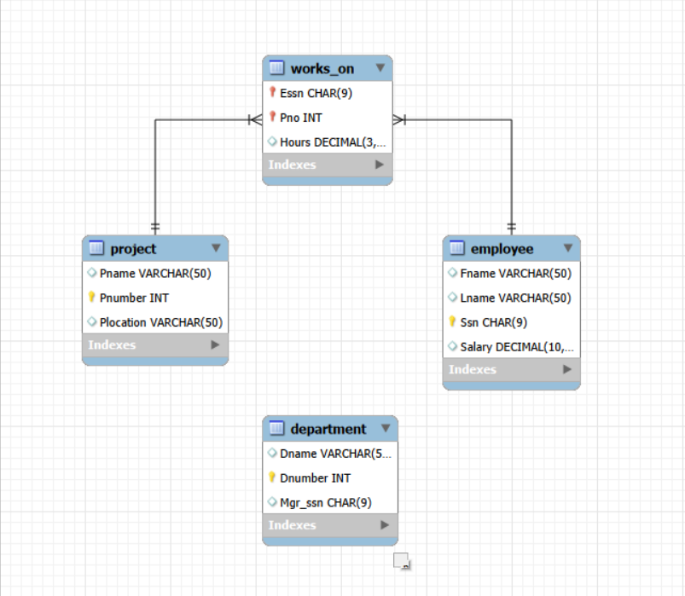

Conclusion :
create databases, define complex table structures, link them via constraints, and visualize the entire system through professional modeling tools.

